JDK8

集合源码学习

**方小白**

**fangjiaxiaobai@163.com**

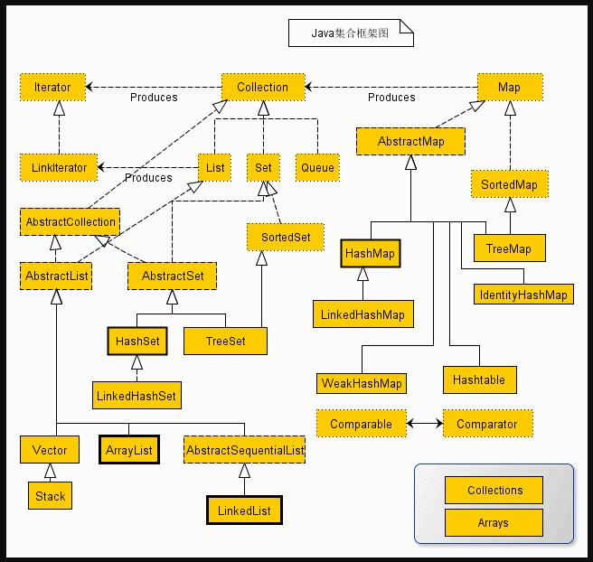

jdk源码学习一 java.util.ArrayList (since 1.2)签名

|  |
| --- |
| **public class ArrayList<E> extends AbstractList<E>**  **implements List<E>, RandomAccess, Cloneable, java.io.Serializable** |

**可序列化，可以支持快速的随机访问，可以被克隆。**

1. **成员变量**

|  |
| --- |
| **private static final int DEFAULT_CAPACITY = 10; // 默认大小为10** |
| **private static final Object[] EMPTY_ELEMENTDATA = {};** |
| **private static final Object[] DEFAULTCAPACITY_EMPTY_ELEMENTDATA = {};** |
| **transient Object[] elementData; // arrayList中的数据** |
| **private int size; // 当前状态下的arraylist中的数据量。** |
| **Protect transient int modCount = 0; // 记录被修改的次数。** |

1. **构造方法**

|  |
| --- |
| **public ArrayList(int initialCapacity) { // 可以指定容量的大小。**  **if (initialCapacity > 0) { //如果指定了容量大小，那么就会创建指定容量的list**  **this.elementData = new Object[initialCapacity];**  **} else if (initialCapacity == 0) {**  **this.elementData = EMPTY_ELEMENTDATA;**  **} else {**  **throw new IllegalArgumentException("Illegal Capacity: "+**  **initialCapacity);**  **}**  **}** |
| **public ArrayList() {**  **this.elementData = DEFAULTCAPACITY_EMPTY_ELEMENTDATA; //使用默认的数据大小**  **}//但是，DEFAULTCAPACITY_EMPTY_ELEMENTDATA的大小也是0，为什么呢？是在第一次调用add的时候将其初始化的。见add方法。** |
| **public ArrayList(Collection<? extends E> c) {**  **elementData = c.toArray();**  **if ((size = elementData.length) != 0) {**  **// c.toArray might (incorrectly) not return Object[] (see 6260652)**  **if (elementData.getClass() != Object[].class)**  **elementData = Arrays.copyOf(elementData, size, Object[].class);**  **} else {**  **// replace with empty array.**  **this.elementData = EMPTY_ELEMENTDATA;**  **}**  **}** |

1. **成员方法**
   1. **add**

|  |
| --- |
| **public boolean add(E e) {**  **ensureCapacityInternal(size + 1); // Increments modCount!!**  **elementData[size++] = e;**  **return true;**  **}** |
| **private void ensureCapacityInternal(int minCapacity) { //minCapacity当前的容量**  **if (elementData == DEFAULTCAPACITY_EMPTY_ELEMENTDATA) {//此时即第一次add**  **minCapacity = Math.max(DEFAULT_CAPACITY, minCapacity);//设置容量为10**  **}**  **ensureExplicitCapacity(minCapacity); // 需要的最小容量。**  **}** |
| **private void ensureExplicitCapacity(int minCapacity) {**  **modCount++;**  **// overflow-conscious code**  **if (minCapacity - elementData.length > 0) //需要扩容了。**  **grow(minCapacity); //扩容的大小为目前的size+1**  **}** |
| **private void grow(int minCapacity) {**  **// overflow-conscious code**  **int oldCapacity = elementData.length;**  **int newCapacity = oldCapacity + (oldCapacity >> 1);**  **if (newCapacity - minCapacity < 0)**  **newCapacity = minCapacity;**  **if (newCapacity - MAX_ARRAY_SIZE > 0)**  **newCapacity = hugeCapacity(minCapacity);**  **// minCapacity is usually close to size, so this is a win:**  **elementData = Arrays.copyOf(elementData, newCapacity);**  **}** |
| **private static int hugeCapacity(int minCapacity) {**  **if (minCapacity < 0) // overflow**  **throw new OutOfMemoryError();**  **return (minCapacity > MAX_ARRAY_SIZE) ?**  **Integer.MAX_VALUE :**  **MAX_ARRAY_SIZE;// Integer.MAX_VALUE-8**  **}** |

**扩容的算法是：**

1. **指定下次预期扩容的为当前容量的二分之三倍，称之为新容量(newCapacity)，如果需要的最小容量(minCapacity)大于新容量(newCapacity)，那么就以需要的最小容量(minCapacity)扩容。如果新容量(newCapacity)大于了规定的最大数组大小(Integr.MAX_VALUE-8)，那么就将需要的最小容量(minCapacity)和最大数组大小(Integr.MAX_VALUE-8)比较，取大。如果最小容量(minCapacity)大于规定的最大数组大小(Integr.MAX_VALUE-8)，扩容后的数组大小为Integr.MAX_VALUE**

**1.2 public void add(int index,E element)**

|  |
| --- |
| **public void add(int index, E element) {**  **rangeCheckForAdd(index);**  **ensureCapacityInternal(size + 1); // Increments modCount!!**  **System.arraycopy(elementData, index, elementData, index + 1,**  **size - index);**  **elementData[index] = element;**  **size++;**  **}** |
| **public static native void arraycopy(Object src, int srcPos,**  **Object dest, int destPos, int length);** |

**添加一个集合中的所有元素的时候，调用的是System.arraycopy方法。注意，调用的这个方法是一个本地方法。**

**1.3 public boolean addAll(Collection<? extends E> c)**

|  |
| --- |
| **public boolean addAll(Collection<? extends E> c) {**  **Object[] a = c.toArray();**  **int numNew = a.length;**  **ensureCapacityInternal(size + numNew); // Increments modCount**  **System.arraycopy(a, 0, elementData, size, numNew);**  **size += numNew;**  **return numNew != 0;**  **}** |

**\* System.arraycopy**

**像其他的和添加相关的方法都是差不多了。不一一列举。**

**2.1 public E remove(int index)**

|  |
| --- |
| **public E remove(int index) {**  **rangeCheck(index);**  **modCount++;**  **E oldValue = elementData(index);**  **int numMoved = size - index - 1;**  **if (numMoved > 0)**  **System.arraycopy(elementData, index+1, elementData, index,**  **numMoved);**  **elementData[--size] = null; // clear to let GC do its work**  **return oldValue;**  **}** |

**很简单，不多说。**

**2.2 public boolean remove(Object o)**

|  |
| --- |
| **public boolean remove(Object o) {**  **if (o == null) {**  **for (int index = 0; index < size; index++)**  **if (elementData[index] == null) {**  **fastRemove(index);**  **return true;**  **}**  **} else {**  **for (int index = 0; index < size; index++)**  **if (o.equals(elementData[index])) {**  **fastRemove(index);**  **return true;**  **}**  **}**  **return false;**  **}** |
| **private void fastRemove(int index) {**  **modCount++;**  **int numMoved = size - index - 1;**  **if (numMoved > 0)**  **System.arraycopy(elementData, index+1, elementData, index,**  **numMoved);**  **elementData[--size] = null; // clear to let GC do its work**  **}** |

**同样的 内涵之处还是在System.arraycopy**

**2.3 public boolean removeAll(Collection<?> c)**

|  |
| --- |
| **public boolean removeAll(Collection<?> c) {**  **Objects.requireNonNull(c);**  **return batchRemove(c, false);**  **}** |
| **private boolean batchRemove(Collection<?> c, boolean complement) {**  **final Object[] elementData = this.elementData;**  **int r = 0, w = 0;**  **boolean modified = false;**  **try {**  **for (; r < size; r++)**  **if (c.contains(elementData[r]) == complement)**  **elementData[w++] = elementData[r];**  **} finally {**  **// Preserve behavioral compatibility with AbstractCollection,**  **// even if c.contains() throws.**  **if (r != size) {**  **System.arraycopy(elementData, r,**  **elementData, w,**  **size - r);**  **w += size - r;**  **}**  **if (w != size) {**  **// clear to let GC do its work**  **for (int i = w; i < size; i++)**  **elementData[i] = null;**  **modCount += size - w;**  **size = w;**  **modified = true;**  **}**  **}**  **return modified;**  **}** |

**3.1 public E get(int index)**

|  |
| --- |
| **public E get(int index) {**  **rangeCheck(index);**  **return elementData(index);**  **}** |
| **E elementData(int index) {**  **return (E) elementData[index]; // 毕竟是数组。**  **}** |

**4. public E set(int index, E element)**

|  |
| --- |
| **public E set(int index, E element) {**  **rangeCheck(index);**  **E oldValue = elementData(index);**  **elementData[index] = element; //数组的性质、**  **return oldValue;**  **}** |

**5. public boolean contains(Object o)**

|  |
| --- |
| **public boolean contains(Object o) {**  **return indexOf(o) >= 0;**  **}** |
| **public int indexOf(Object o) {**  **if (o == null) {**  **for (int i = 0; i < size; i++)**  **if (elementData[i]==null)**  **return i;**  **} else {**  **for (int i = 0; i < size; i++)**  **if (o.equals(elementData[i]))**  **return i;**  **}**  **return -1;**  **}** |

1. **遍历方式**
2. **for循环。**
3. **fori**
4. **Iterator、ArrayList.iterator();**

|  |
| --- |
| **public Iterator<E> iterator() { return new Itr(); }** |
| **private class Itr implements Iterator<E> {**  **int cursor; // index of next element to return**  **int lastRet = -1; // index of last element returned; -1 if no such**  **int expectedModCount = modCount;**  **public boolean hasNext() {**  **return cursor != size;**  **}**  **@SuppressWarnings("unchecked")**  **public E next() {**  **checkForComodification();**  **int i = cursor; // cursor 当前元素的指针。**  **if (i >= size)**  **throw new NoSuchElementException();**  **Object[] elementData = ArrayList.this.elementData;**  **if (i >= elementData.length)**  **throw new ConcurrentModificationException();**  **cursor = i + 1;**  **return (E) elementData[lastRet = i];**  **}**  **public void remove() {**  **if (lastRet < 0)**  **throw new IllegalStateException();**  **checkForComodification();**  **try {**  **ArrayList.this.remove(lastRet);**  **cursor = lastRet;**  **lastRet = -1;**  **expectedModCount = modCount;**  **} catch (IndexOutOfBoundsException ex) {**  **throw new ConcurrentModificationException();**  **}**  **}**  **@Override**  **@SuppressWarnings("unchecked")**  **public void forEachRemaining(Consumer<? super E> consumer) {**  **Objects.requireNonNull(consumer);**  **final int size = ArrayList.this.size;**  **int i = cursor;**  **if (i >= size) {**  **return;**  **}**  **final Object[] elementData = ArrayList.this.elementData;**  **if (i >= elementData.length) {**  **throw new ConcurrentModificationException();**  **}**  **while (i != size && modCount == expectedModCount) {**  **consumer.accept((E) elementData[i++]);**  **}**  **// update once at end of iteration to reduce heap write traffic**  **cursor = i;**  **lastRet = i - 1;**  **checkForComodification();**  **}**  **final void checkForComodification() {**  **if (modCount != expectedModCount)**  **throw new ConcurrentModificationException();**  **}**  **}** |

**定义了一个内部类，实现了Iterator接口。实现其方法。**

**用一个变量来记录当前访问的元素的地址，这个变量必须是成员变量。**

**不定义内部类，直接用ArrayList实现Iterator接口，也是可以的。**

**总结：**

**先说一些老生常谈的事情吧。**

**1.ArrayList的实现原理是数组。**

**2.容量不固定，最大值是Integer.MAX**

**3.元素允许为null。**

**4.有序(重申:放入和取出是有序的)**

**5.非线程安全。**

**并发环境下，要么加锁，要么在初始化时使用Collection.synchronizeList(new ArrayList());**

**6.遍历时的效率问题：**

**for循环要比迭代器快。原因是ArrayList继承了RandomAccess，支持快速的随机访问，而迭代器都是基于ArrayList方法和数组直接操作的。**

**7.add，remove值类型的数据时可能会涉及拆装箱操作。**

**补充一下：**

**Fail-fast机制，也叫作快速失败机制，是java集合中的一种错误检测机制。**

**ArrayList中，有个modCount的变量，每次进行add，set，remove等操作，都会执行modCount++.**

**在获取ArrayList迭代器时，会将ArrayList中的modCount保存在迭代中，每次执行add，set，remove等操作，都会执行一次检查，都会调用checkForComodification方法，对modCount进行比较，如果迭代器中的modCount和list中的modCount不同，就会抛出ConcurrentModificationException。**

jdk源码学习二 java.util.LinkedList (since 1.2)

1. **签名**

|  |
| --- |
| **public class LinkedList<E>**  **extends AbstractSequentialList<E>**  **implements List<E>, Deque<E>, Cloneable, java.io.Serializable** |

1. **继承了AbstractSequentialList<>**
2. **实现了Deque：出现在1.6，继承了Queue。双端队列容器，不仅可以在尾部插入，删除元素，还可以在头部插入和删除元素。**
3. **Clone: 可以克隆**
4. **Serializable：可被序列化**
5. **成员变量**

|  |
| --- |
| **trainsient int size = 0;** |
| **Transient Node<E> first; // 记录第一个。** |
| **Transient Node<E> last; // 只记录当前的节点，也是最后一个** |
| **protected transient int modCount = 0; //记录当前对LinkedList修改的次数** |
| **private static class Node<E> {**  **E item;**  **Node<E> next;**  **Node<E> prev;**  **Node(Node<E> prev, E element, Node<E> next) {**  **this.item = element;**  **this.next = next;**  **this.prev = prev;**  **}**  **}** |

1. **构造方法**

|  |
| --- |
| **public LinkedList() {**  **}** |
| **public LinkedList(Collection<? extends E> c) {**  **this();**  **addAll(c);**  **}** |

1. **成员方法**

**1.1 .add(E e)**

|  |
| --- |
| **public boolean add(E e) {**  **linkLast(e);**  **return true;**  **}** |
| **void linkLast(E e) {**  **final Node<E> l = last;**  **final Node<E> newNode = new Node<>(l, e, null);**  **last = newNode;**  **if (l == null)**  **first = newNode;**  **else**  **l.next = newNode;**  **size++;**  **modCount++;**  **}** |

* 1. **add(int index,E element)**

|  |
| --- |
| **public void add(int index, E element) {**  **checkPositionIndex(index);**  **if (index == size) // 如果插入的位置是最后一个，**  **linkLast(element);**  **else**  **linkBefore(element, node(index));**  **}** |
| **void linkLast(E e) 见上** |
| **void linkBefore(E e, Node<E> succ) {**  **// assert succ != null;**  **final Node<E> pred = succ.prev;**  **final Node<E> newNode = new Node<>(pred, e, succ);**  **succ.prev = newNode;**  **if (pred == null)**  **first = newNode;**  **else**  **pred.next = newNode;**  **size++;**  **modCount++;**  **}** |

* 1. **push();**

|  |
| --- |
| **public void push(E e) {**  **addFirst(e); // 不知道为什么 不直接使用linkFirst(e)**  **}** |
| **public void addFirst(E e) {**  **linkFirst(e);**  **}** |
| **private void linkFirst(E e) {**  **final Node<E> f = first;**  **final Node<E> newNode = new Node<>(null, e, f);//注意linkLast的不同之处。**  **first = newNode;**  **if (f == null)**  **last = newNode;**  **else**  **f.prev = newNode;**  **size++;**  **modCount++;**  **}** |

**2.1.remove()**

|  |
| --- |
| **public E remove() {**  **return removeFirst();**  **}** |
| **public E removeFirst() {**  **final Node<E> f = first;**  **if (f == null)**  **throw new NoSuchElementException();**  **return unlinkFirst(f);**  **}** |
| **private E unlinkFirst(Node<E> f) {**  **// assert f == first && f != null;**  **final E element = f.item;**  **final Node<E> next = f.next;**  **f.item = null;**  **f.next = null; // help GC**  **first = next;**  **if (next == null)**  **last = null;**  **else**  **next.prev = null;**  **size--;**  **modCount++;**  **return element;**  **}** |

**2.2 removeFirst()**

**2.3 removeLast()**

**2.4 remove(int index)**

|  |
| --- |
| **public E remove(int index) {**  **checkElementIndex(index);**  **return unlink(node(index));**  **}** |
| **Node<E> node(int index) {**  **// assert isElementIndex(index);**  **if (index < (size >> 1)) { // 二分查找。**  **Node<E> x = first;**  **for (int i = 0; i < index; i++)**  **x = x.next;**  **return x;**  **} else {**  **Node<E> x = last;**  **for (int i = size - 1; i > index; i--)**  **x = x.prev;**  **return x;**  **}**  **}** |
| **E unlink(Node<E> x) {**  **// assert x != null;**  **final E element = x.item;**  **final Node<E> next = x.next;**  **final Node<E> prev = x.prev;**  **if (prev == null) {**  **first = next;**  **} else {**  **prev.next = next;**  **x.prev = null;**  **}**  **if (next == null) {**  **last = prev;**  **} else {**  **next.prev = prev;**  **x.next = null;**  **}**  **x.item = null;**  **size--;**  **modCount++;**  **return element;**  **}** |

**2.5 public E pop()**

|  |
| --- |
| **public E pop() {**  **return removeFirst();**  **}** |

**3.1 public E set(int index,E element)**

|  |
| --- |
| **public E set(int index, E element) {**  **checkElementIndex(index);**  **Node<E> x = node(index);**  **E oldVal = x.item;**  **x.item = element;**  **return oldVal;**  **}** |

* 1. **public E get(int index)**

|  |
| --- |
| **public E get(int index) {**  **checkElementIndex(index);**  **return node(index).item;**  **}** |

* 1. **public E peekFirst()**

|  |
| --- |
| **public E peekFirst() {**  **final Node<E> f = first;**  **return (f == null) ? null : f.item;**  **}** |

* 1. **public E peekLast()**

|  |
| --- |
| **public E peekLast() {**  **final Node<E> l = last;**  **return (l == null) ? null : l.item;**  **}** |

1. **public Boolean contains(Object o)**

|  |
| --- |
| **public boolean contains(Object o) {**  **return indexOf(o) != -1;**  **}** |
| **public int indexOf(Object o) { // 这种方式就是挨个遍历。**  **int index = 0;**  **if (o == null) {**  **for (Node<E> x = first; x != null; x = x.next) {**  **if (x.item == null)**  **return index;**  **index++;**  **}**  **} else {**  **for (Node<E> x = first; x != null; x = x.next) {**  **if (o.equals(x.item))**  **return index;**  **index++;**  **}**  **}**  **return -1;**  **}** |

1. **public void clear()**

|  |
| --- |
| **public void clear() { // 将所有都置为null，help GC**  **for (Node<E> x = first; x != null; ) {**  **Node<E> next = x.next;**  **x.item = null;**  **x.next = null;**  **x.prev = null;**  **x = next;**  **}**  **first = last = null;**  **size = 0;**  **modCount++;**  **}** |

1. **遍历方式**
2. **for**
3. **fori**
4. **iterator()**

**总结：**

1. **原理是链表。**
2. **有序**
3. **非线程安全**
4. **元素允许为null**
5. **遍历时候for,都会调用node(index)方法。**
6. **效率问题：**

**很多文章都再说，arrayList查找快，增删慢，LinkedList增删快，查找慢。**

**这种说法不准确：**

**（1）LinkedList做插入、删除的时候，慢在寻址，快在只需要改变前后Entry的引用地址**

**（2）ArrayList做插入、删除的时候，慢在数组元素的批量copy，快在寻址**

**所以，如果待插入、删除的元素是在数据结构的前半段尤其是非常靠前的位置的时候，LinkedList的效率将大大快过ArrayList，因为ArrayList将批量copy大量的元素；越往后，对于LinkedList来说，因为它是双向链表，所以在第2个元素后面插入一个数据和在倒数第2个元素后面插入一个元素在效率上基本没有差别，但是ArrayList由于要批量copy的元素越来越少，操作速度必然追上乃至超过LinkedList。**

**从这个分析看出，如果你十分确定你插入、删除的元素是在前半段，那么就使用LinkedList；如果你十分确定你删除、删除的元素在比较靠后的位置，那么可以考虑使用ArrayList。如果你不能确定你要做的插入、删除是在哪儿呢？那还是建议你使用LinkedList吧，因为一来LinkedList整体插入、删除的执行效率比较稳定，没有ArrayList这种越往后越快的情况；二来插入元素的时候，弄得不好ArrayList就要进行一次扩容，记住，ArrayList底层数组扩容是一个既消耗时间又消耗空间的操作，**

jdk源码分析三 java.util. Vector （since 1.0）

1. **签名**

|  |
| --- |
| **public class Vector<E>**  **extends AbstractList<E>**  **implements List<E>, RandomAccess, Cloneable, java.io.Serializable** |

1. **成员变量**

|  |
| --- |
| **Protect Object[] elementData;** |
| **Protect int elementCount;** |
| **Protect int capacitIncrement;** |
|  |

1. **构造方法**

|  |
| --- |
| **public Vector(int initialCapacity, int capacityIncrement) {**  **super();**  **if (initialCapacity < 0)**  **throw new IllegalArgumentException("Illegal Capacity: "+**  **initialCapacity);**  **this.elementData = new Object[initialCapacity];**  **this.capacityIncrement = capacityIncrement;**  **}** |
| **public Vector(int initialCapacity) {**  **this(initialCapacity, 0);**  **}** |
| **public Vector() {**  **this(10); //vector的默认初始化大小为10**  **}** |

1. **成员方法**

**Vector和ArrayList差不多。不同的是Vector的方法上加上了synchronized关键字。这表明Vector的线程同步的，线程安全的。**

1. **add()**

|  |
| --- |
| **public synchronized void addElement(E obj) {**  **modCount++;**  **ensureCapacityHelper(elementCount + 1);**  **elementData[elementCount++] = obj;**  **}** |
| **private void ensureCapacityHelper(int minCapacity) {**  **// overflow-conscious code**  **if (minCapacity - elementData.length > 0)**  **grow(minCapacity);**  **}** |
| **private void grow(int minCapacity) {**  **// overflow-conscious code**  **int oldCapacity = elementData.length;**  **int newCapacity = oldCapacity + ((capacityIncrement > 0) ?**  **capacityIncrement : oldCapacity);**  **if (newCapacity - minCapacity < 0) //**  **newCapacity = minCapacity;**  **if (newCapacity - MAX_ARRAY_SIZE > 0)**  **newCapacity = hugeCapacity(minCapacity);**  **elementData = Arrays.copyOf(elementData, newCapacity);**  **}** |
| **private static int hugeCapacity(int minCapacity) {**  **if (minCapacity < 0) // overflow**  **throw new OutOfMemoryError();**  **return (minCapacity > MAX_ARRAY_SIZE) ?**  **Integer.MAX_VALUE :**  **MAX_ARRAY_SIZE;**  **}** |

**扩容的算法：如果没有指定扩容大小，那么就默认扩容增量为当前的容量+1，则扩容后的大小为两倍的当前容量+1，称之为新容量。如果新容量小于需要的容量大小，那将这个需要的容量赋值给新容量，如果新容量大于最大的数组大小，那么扩容到最大，即MAX_ARRAY_SIZE。**

|  |
| --- |
| **public synchronized void insertElementAt(E obj, int index) {**  **modCount++;**  **if (index > elementCount) {**  **throw new ArrayIndexOutOfBoundsException(index**  **+ " > " + elementCount);**  **}**  **ensureCapacityHelper(elementCount + 1);**  **System.arraycopy(elementData, index, elementData, index + 1, elementCount - index);**  **elementData[index] = obj;**  **elementCount++;**  **}** |

**关键还是在判断容量上。**

1. **remove()**

|  |
| --- |
| **public synchronized boolean removeElement(Object obj) {**  **modCount++;**  **int i = indexOf(obj);**  **if (i >= 0) {**  **removeElementAt(i);**  **return true;**  **}**  **return false;**  **}** |
| **public int indexOf(Object o) {**  **return indexOf(o, 0);**  **}** |
| **public synchronized int indexOf(Object o, int index) {**  **if (o == null) {**  **for (int i = index ; i < elementCount ; i++)**  **if (elementData[i]==null)**  **return i;**  **} else {**  **for (int i = index ; i < elementCount ; i++)**  **if (o.equals(elementData[i]))**  **return i;**  **}**  **return -1;**  **}** |
| **public synchronized void removeElementAt(int index) {**  **modCount++;**  **if (index >= elementCount) {**  **throw new ArrayIndexOutOfBoundsException(index + " >= " +**  **elementCount);**  **}**  **else if (index < 0) {**  **throw new ArrayIndexOutOfBoundsException(index);**  **}**  **int j = elementCount - index - 1;**  **if (j > 0) {**  **System.arraycopy(elementData, index + 1, elementData, index, j);**  **}**  **elementCount--;**  **elementData[elementCount] = null; /* to let gc do its work */**  **}** |

1. **public boolean contains(Object o)**

|  |
| --- |
| **public boolean contains(Object o) {**  **return indexOf(o, 0) >= 0;**  **}** |
| **indexOf(),见上。** |

|  |
| --- |
| **public synchronized E firstElement() {**  **if (elementCount == 0) {**  **throw new NoSuchElementException();**  **}**  **return elementData(0);**  **}** |
| **public synchronized E lastElement() {**  **if (elementCount == 0) {**  **throw new NoSuchElementException();**  **}**  **return elementData(elementCount - 1);**  **}** |

1. **遍历方式**

|  |
| --- |
| **public Enumeration<E> elements() {**  **return new Enumeration<E>() {**  **int count = 0;**  **public boolean hasMoreElements() {**  **return count < elementCount;**  **}**  **public E nextElement() {**  **synchronized (Vector.this) {**  **if (count < elementCount) {**  **return elementData(count++);**  **}**  **}**  **throw new NoSuchElementException("Vector Enumeration");**  **}**  **};**  **}** |

**for**

**fori**

**Iterator**

**总结**

**允许元素为空。**

**有序**

**线程安全**

jdk源码分析四 java.util.HashMap （since 1.2）

**本来是想写HashSet,但是看了HashSet的成员变量，你就懂了、、、、、**

1. **签名**

|  |
| --- |
| **public class HashMap<K,V> extends AbstractMap<K,V>**  **implements Map<K,V>, Cloneable, Serializable {** |

**HashMap通常作为桶式哈希表，当桶变得很大的时候就转化为树节点。一般达到过量数据的时机比较少。所以在桶式哈希表中会尽量推迟树形节点的检测。**

**树形哈希（所有节点都是树节点），以哈希值排序，但如果都是同类型并且该类型实现了比较器就以比较器的结果为准。TreeNode是一般节点的两倍。只有当哈希表节点数达到一定数量才使用。**

**通常第一个节点作为树的根节点，当根节点移除时才更换。**

**不论哈希列表还是树形哈希，分割还是非树形，都保证相对的访问遍历顺序。**

1. **成员变量**

|  |
| --- |
| **static final int DEFAULT_INITIAL_CAPACITY = 1 << 4; // 初始大小16** |
| **static final int MAXIMUM_CAPACITY = 1 << 30; // 最大容量** |
| **static final float DEFAULT_LOAD_FACTOR = 0.75f; //负载系数(装载因子)**  **主要控制空间利用率和冲突。装载因子越大空间利用率更高，冲突可能也会变大，反之则相反。** |
| **static final int TREEIFY_THRESHOLD = 8; //由链表转换成树的阈值、** |
| **static final int UNTREEIFY_THRESHOLD = 6; // 由树转换成链表的阈值** |
| **static final int MIN_TREEIFY_CAPACITY = 64; //转换树形后表格最小容量，至少是treeify_threshold的四倍。** |
| **static class Node<K,V> implements Map.Entry<K,V> { //基本的哈希容器节点。**  **final int hash; // 不可变的hash值，由关键字key得来。**  **final K key; // 关键字不可变**  **V value;**  **Node<K,V> next;**  **Node(int hash, K key, V value, Node<K,V> next) {**  **this.hash = hash;**  **this.key = key;**  **this.value = value;**  **this.next = next;**  **}**  **public final K getKey() { return key; }**  **public final V getValue() { return value; }**  **public final String toString() { return key + "=" + value; }**  **public final int hashCode() { // 异或运算。**  **return Objects.hashCode(key) ^ Objects.hashCode(value);**  **}**  **public final V setValue(V newValue) {**  **V oldValue = value;**  **value = newValue;**  **return oldValue;**  **}**  **public final boolean equals(Object o) {**  **if (o == this)**  **return true;**  **if (o instanceof Map.Entry) {**  **Map.Entry<?,?> e = (Map.Entry<?,?>)o;**  **if (Objects.equals(key, e.getKey()) &&**  **Objects.equals(value, e.getValue()))**  **return true;**  **}**  **return false;**  **}**  **}** |
| **transient Node<K,V>[] table; // 不被序列化的节点。Node类型数组，第一次使用的时候初始化，必要时重新分配空间。长度总是2的次幂。** |
| **static class Node<K,V> implements Map.Entry<K,V> {**  **final int hash;**  **final K key;**  **V value;**  **Node<K,V> next;**  **Node(int hash, K key, V value, Node<K,V> next) {**  **this.hash = hash;**  **this.key = key;**  **this.value = value;**  **this.next = next;**  **}**  **public final K getKey() { return key; }**  **public final V getValue() { return value; }**  **public final String toString() { return key + "=" + value; }**  **public final int hashCode() {**  **return Objects.hashCode(key) ^ Objects.hashCode(value);**  **}**  **public final V setValue(V newValue) {**  **V oldValue = value;**  **value = newValue;**  **return oldValue;**  **}**  **public final boolean equals(Object o) {**  **if (o == this)**  **return true;**  **if (o instanceof Map.Entry) {**  **Map.Entry<?,?> e = (Map.Entry<?,?>)o;**  **if (Objects.equals(key, e.getKey()) &&**  **Objects.equals(value, e.getValue()))**  **return true;**  **}**  **return false;**  **}**  **}** |
| **transient Set<Map.Entry<K,V>> entrySet; // 缓存所有的EntrySet()** |
| **transient int size; // 当前map中的数据量** |
| **transient int modCount; // map结构的修改次数。实现了fast-fial策略。** |
| **int threshold; // 下次重新分配空间resize()时，table数组的大小。** |
| **Final float loadFactor; // hash表的负载因子。** |

1. **静态工具函数。**

|  |
| --- |
| **static final int hash(Object key) {**  **int h;**  **return (key == null) ? 0 : (h = key.hashCode()) ^ (h >>> 16);**  **} // 学习一下编码风格(标红处)。** |

**计算key的hash值，并且将高位的hash值移到低位。因为使用的掩码是2的n次幂，高于掩码的位组成的哈希集合总是冲突，所以要把高位移到低位。**

|  |
| --- |
| **static Class<?> comparableClassFor(Object x) {**  **if (x instanceof Comparable) {**  **Class<?> c; Type[] ts, as; Type t; ParameterizedType p;**  **if ((c = x.getClass()) == String.class) // bypass checks**  **return c;**  **if ((ts = c.getGenericInterfaces()) != null) {**  **for (int i = 0; i < ts.length; ++i) {**  **if (((t = ts[i]) instanceof ParameterizedType) &&**  **((p = (ParameterizedType)t).getRawType() ==**  **Comparable.class) &&**  **(as = p.getActualTypeArguments()) != null &&**  **as.length == 1 && as[0] == c) // type arg is c**  **return c;**  **}**  **}**  **}**  **return null;**  **}** |

**与x进行比较，如果x是可比较类型,返回x的类型，否则返回null。**

|  |
| --- |
| **static int compareComparables(Class<?> kc, Object k, Object x) {**  **return (x == null || x.getClass() != kc ? 0 :**  **((Comparable)k).compareTo(x));**  **}** |

**如果x和k可以比较，返回k和x的比较结果，否则返回0.**

|  |
| --- |
| **static final int tableSizeFor(int cap) {**  **int n = cap - 1;**  **n |= n >>> 1;**  **n |= n >>> 2;**  **n |= n >>> 4;**  **n |= n >>> 8;**  **n |= n >>> 16;**  **return (n < 0) ? 1 : (n >= MAXIMUM_CAPACITY) ? MAXIMUM_CAPACITY : n + 1;**  **}** |

**对于给定的目标容器返回一个2的次幂容量(返回大于cap的最小的2次幂)*感觉这个地方很深奥。***

**百度一张图片吧：**

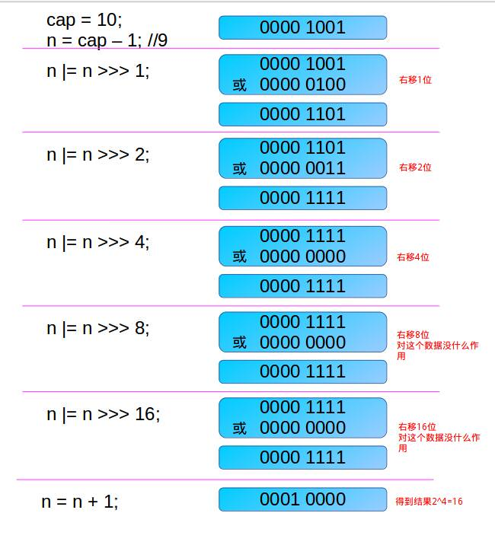

1. **构造方法**

|  |
| --- |
| **public HashMap(int initialCapacity, float loadFactor) {**  **if (initialCapacity < 0)**  **throw new IllegalArgumentException("Illegal initial capacity: " +**  **initialCapacity);**  **if (initialCapacity > MAXIMUM_CAPACITY)**  **initialCapacity = MAXIMUM_CAPACITY;**  **if (loadFactor <= 0 || Float.isNaN(loadFactor))**  **throw new IllegalArgumentException("Illegal load factor: " +**  **loadFactor);**  **this.loadFactor = loadFactor;**  **this.threshold = tableSizeFor(initialCapacity);**  **}** |

**根据特定的初始化容量和负载因子的构造函数。**

|  |
| --- |
| **public HashMap(int initialCapacity) {**  **this(initialCapacity, DEFAULT_LOAD_FACTOR);**  **}** |

**根据指定初始化容量和默认装载因子.75的构造函数**

|  |
| --- |
| **public HashMap() {**  **this.loadFactor = DEFAULT_LOAD_FACTOR; // all other fields defaulted**  **}** |

**构造一个默认大小和默认装载因子的HashMap。**

|  |
| --- |
| **public HashMap(Map<? extends K, ? extends V> m) {**  **this.loadFactor = DEFAULT_LOAD_FACTOR;**  **putMapEntries(m, false);**  **}** |

1. **成员方法**

|  |
| --- |
| **public V put(K key, V value) {**  **return putVal(hash(key), key, value, false, true);**  **}** |
| **final V putVal(int hash, K key, V value, boolean onlyIfAbsent,**  **boolean evict) {**  **Node<K,V>[] tab; Node<K,V> p; int n, i;**  **// 如果table为空的话，就先初始化，扩容。**  **if ((tab = table) == null || (n = tab.length) == 0)**  **n = (tab = resize()).length;**  **if ((p = tab[i = (n - 1) & hash]) == null) // 如果tab[i]为空，直接放入。**  **tab[i] = newNode(hash, key, value, null);**  **else { // 如果hash后的位置上的值不为空。后接链表。**  **Node<K,V> e; K k;**  **if (p.hash == hash &&**  **((k = p.key) == key || (key != null && key.equals(k)))) // key已经存在。**  **e = p;**  **else if (p instanceof TreeNode) // 如果该节点属于红黑树。(链表的长度>8)**  **e = ((TreeNode<K,V>)p).putTreeVal(this, tab, hash, key, value);**  **else {// tab[i]后还是链表。**  **for (int binCount = 0; ; ++binCount) {**  **if ((e = p.next) == null) { //遍历到链表的最后一个元素。**  **p.next = newNode(hash, key, value, null);**  **if (binCount >= TREEIFY_THRESHOLD - 1) // -1 for 1st**  **treeifyBin(tab, hash); //将链表转换成红黑树。**  **break;**  **}**  **if (e.hash == hash &&**  **((k = e.key) == key || (key != null && key.equals(k))))//如果key已经存在，就覆盖value。**  **break;**  **p = e;**  **}**  **}**  **//如果之前判断到key已经存在，就进行覆盖value**  **if (e != null) { // existing mapping for key**  **V oldValue = e.value;**  **if (!onlyIfAbsent || oldValue == null)**  **e.value = value;**  **afterNodeAccess(e);**  **return oldValue;**  **}**  **}**  **++modCount;**  **if (++size > threshold)**  **resize();**  **afterNodeInsertion(evict);**  **return null;**  **}** |
| **扩容机制：**  **final Node<K,V>[] resize() {**  **Node<K,V>[] oldTab = table;**  **int oldCap = (oldTab == null) ? 0 : oldTab.length;**  **int oldThr = threshold;**  **int newCap, newThr = 0;**  **if (oldCap > 0) {**  **if (oldCap >= MAXIMUM_CAPACITY) { // 如果原来table中容量已经是最大**  **threshold = Integer.MAX_VALUE;**  **return oldTab;**  **}**  **// 如果旧容量*2小于最大容量阈值，并且旧容量大于默认初始化容量。**  **else if ((newCap = oldCap << 1) < MAXIMUM_CAPACITY &&**  **oldCap >= DEFAULT_INITIAL_CAPACITY)**  **newThr = oldThr << 1; // 新的容量阈值扩大两倍。**  **}**  **else if (oldThr > 0) // initial capacity was placed in threshold**  **newCap = oldThr;**  **else { // zero initial threshold signifies using defaults**  **newCap = DEFAULT_INITIAL_CAPACITY;**  **newThr = (int)(DEFAULT_LOAD_FACTOR * DEFAULT_INITIAL_CAPACITY);**  **}**  **if (newThr == 0) {**  **float ft = (float)newCap * loadFactor;**  **newThr = (newCap < MAXIMUM_CAPACITY && ft < (float)MAXIMUM_CAPACITY ?**  **(int)ft : Integer.MAX_VALUE);**  **}**  **threshold = newThr;**  **@SuppressWarnings({"rawtypes","unchecked"})**  **Node<K,V>[] newTab = (Node<K,V>[])new Node[newCap];**  **table = newTab;**  **if (oldTab != null) {**  **for (int j = 0; j < oldCap; ++j) { // 把每个table[i]都移动到新的newtable[i]中。**  **Node<K,V> e;**  **if ((e = oldTab[j]) != null) {**  **oldTab[j] = null;**  **if (e.next == null)**  **newTab[e.hash & (newCap - 1)] = e;**  **else if (e instanceof TreeNode)**  **((TreeNode<K,V>)e).split(this, newTab, j, oldCap);**  **else { // preserve order**  **Node<K,V> loHead = null, loTail = null;**  **Node<K,V> hiHead = null, hiTail = null;**  **Node<K,V> next;**  **do {**  **next = e.next;**  **// 原索引。**  **if ((e.hash & oldCap) == 0) {**  **if (loTail == null)**  **loHead = e;**  **else**  **loTail.next = e;**  **loTail = e;**  **}**  **else { // 原索引+oldCap**  **if (hiTail == null)**  **hiHead = e;**  **else**  **hiTail.next = e;**  **hiTail = e;**  **}**  **} while ((e = next) != null);**  **if (loTail != null) {**  **loTail.next = null;**  **newTab[j] = loHead;**  **}**  **if (hiTail != null) {**  **hiTail.next = null;**  **newTab[j + oldCap] = hiHead;**  **}**  **}**  **}**  **}**  **}**  **return newTab;**  **}** |
| **final TreeNode<K,V> putTreeVal(HashMap<K,V> map, Node<K,V>[] tab,**  **int h, K k, V v) {**  **Class<?> kc = null;**  **boolean searched = false;**  **TreeNode<K,V> root = (parent != null) ? root() : this;**  **for (TreeNode<K,V> p = root;;) {**  **int dir, ph; K pk;**  **if ((ph = p.hash) > h)**  **dir = -1;**  **else if (ph < h)**  **dir = 1;**  **else if ((pk = p.key) == k || (k != null && k.equals(pk)))**  **return p;**  **else if ((kc == null &&**  **(kc = comparableClassFor(k)) == null) ||**  **(dir = compareComparables(kc, k, pk)) == 0) {**  **if (!searched) {**  **TreeNode<K,V> q, ch;**  **searched = true;**  **if (((ch = p.left) != null &&**  **(q = ch.find(h, k, kc)) != null) ||**  **((ch = p.right) != null &&**  **(q = ch.find(h, k, kc)) != null))**  **return q;**  **}**  **dir = tieBreakOrder(k, pk);**  **}**  **TreeNode<K,V> xp = p;**  **if ((p = (dir <= 0) ? p.left : p.right) == null) {**  **Node<K,V> xpn = xp.next;**  **TreeNode<K,V> x = map.newTreeNode(h, k, v, xpn);**  **if (dir <= 0)**  **xp.left = x;**  **else**  **xp.right = x;**  **xp.next = x;**  **x.parent = x.prev = xp;**  **if (xpn != null)**  **((TreeNode<K,V>)xpn).prev = x;**  **moveRootToFront(tab, balanceInsertion(root, x));**  **return null;**  **}**  **}**  **}** |

**分析：**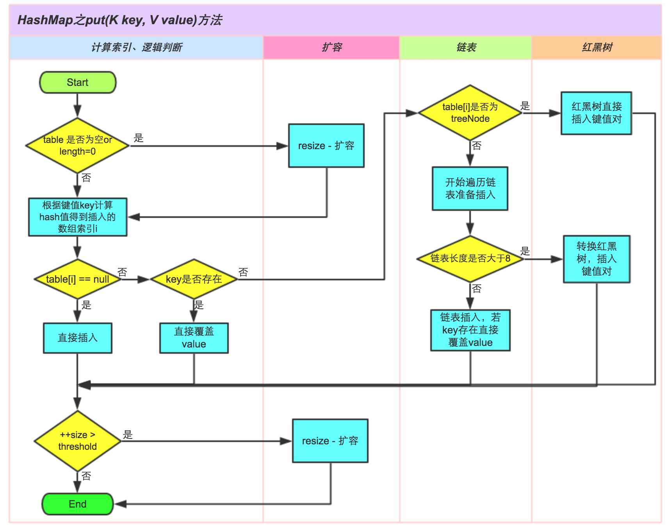

**图片来源于网络，见注释。**

|  |
| --- |
| **public V remove(Object key) {**  **Node<K,V> e;**  **return (e = removeNode(hash(key), key, null, false, true)) == null ?**  **null : e.value;**  **}** |
| **static final int hash(Object key) {**  **int h;**  **return (key == null) ? 0 : (h = key.hashCode()) ^ (h >>> 16);**  **}** |
| **final Node<K,V> removeNode(int hash, Object key, Object value,**  **boolean matchValue, boolean movable) {**  **Node<K,V>[] tab; Node<K,V> p; int n, index;**  **if ((tab = table) != null && (n = tab.length) > 0 &&**  **(p = tab[index = (n - 1) & hash]) != null) {**  **Node<K,V> node = null, e; K k; V v;**  **if (p.hash == hash &&**  **((k = p.key) == key || (key != null && key.equals(k))))**  **node = p;**  **else if ((e = p.next) != null) {**  **if (p instanceof TreeNode)**  **node = ((TreeNode<K,V>)p).getTreeNode(hash, key);**  **else {**  **do {**  **if (e.hash == hash &&**  **((k = e.key) == key ||**  **(key != null && key.equals(k)))) {**  **node = e;**  **break;**  **}**  **p = e;**  **} while ((e = e.next) != null);**  **}**  **}**  **if (node != null && (!matchValue || (v = node.value) == value ||**  **(value != null && value.equals(v)))) {**  **if (node instanceof TreeNode)**  **((TreeNode<K,V>)node).removeTreeNode(this, tab, movable);**  **else if (node == p)**  **tab[index] = node.next;**  **else**  **p.next = node.next;**  **++modCount;**  **--size;**  **afterNodeRemoval(node);**  **return node;**  **}**  **}**  **return null;**  **}** |

1. **遍历方法**

**这里总结一下Map的遍历方法吧，for，fori，iterator什么的统统不算哈。**

**就只有两种。一种是entry，一种是getKey。**

**举个栗子：一对夫妻，你想找个那个妻子。。。。。。一种找到他老公，通过他老公去找，第二种是直接拿到他俩的结婚证找到妻子。**

1. **hashMap.keySet(); for set…………就是for循环的方式了。**
2. **hashMap.entrySet();**

**总结**

**hashMap根据键的hashCode值存储数据，大多数情况下可以直接定位它的值。大多数情况下可以直接定位它的值，因而具有很快的访问速度。但是遍历顺序却是不确定的。hashMap最多只允许一条记录的键为null，允许多条记录的值为null。hashMap非线程安全，即任一时刻可以有多个线程同时写HashMap，可能会导致数据的不一致，但是可以用Collections.synchronizedMap()使HashMap线程安全。**

**或者使用ConcurrentHashMap。**

**要搞清楚HashMap，首先要清楚HashMap是什么，即它的存储结构-字段，其次弄明白它能干什么，即它的功能实现-方法。**

**Jdk8中，HashMap是数组+链表+红黑树实现的，如下图。**

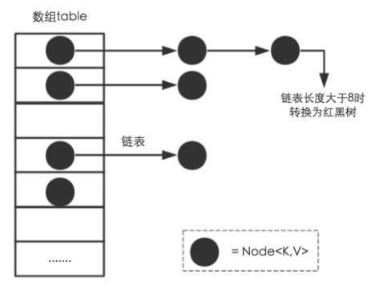

**那么问题来了，数据底层存储的是什么呢？这样的存储方式有什么好处呢？**

**1.hashMap有一个很重要的字段，就是Node<K,V>.这个Node的实现，见上面的字段介绍。**

**途中每个黑点就是一个Node。**

**2.大家都知道HashMap的底层数据结构使哈希表，哈希表为解决冲突，可以采用开发地址法和链地址法等来解决问题，java中HashMap采用了链地址法。当数据被hash后，得到数组下标，把数据放在对应下标元素的链表上。**

**3.根据源码，threshold就是在此loadFactor和length对应下允许的最大元素数目，超过这个数目就要重新扩容，扩容后的HashMap容量就是之前容量的两倍。默认的loadFactor是0.75，是对空间和时间的平衡选择，。如果内存空间很多而对事件效率要求很高，可以降低loadFactor的值。想反，对内存空间比较紧张而对时间效率要求不高的时候，就可以增加loadFactor的值，这个值可以大于1.**

**4.为什么hashMap的重新扩容或者初始化大小是2的n次方呢？**

***在HashMap中，哈希桶数组table的长度length大小必须为2的n次方(一定是合数)，这是一种非常规的设计，常规的设计是把桶的大小设计为素数。相对来说素数导致冲突的概率要小于合数，具体证明可以参考http://blog.csdn.net/liuqiyao_01/article/details/14475159，Hashtable初始化桶大小为11，就是桶大小设计为素数的应用（Hashtable扩容后不能保证还是素数）。HashMap采用这种非常规设计，主要是为了在取模和扩容时做优化，同时为了减少冲突，HashMap定位哈希桶索引位置时，也加入了高位参与运算的过程。***

**5.哈希算法：**

**这里的Hash算法本质上就是三步，取key的hashCode值，，高位运算，取模运算。**

**对于任意的对象，只要hashCode()的值相同，那么计算所得的hash码也是相同的，我们把hash值对数组的长度取模，但是取模的消耗很大，hashMap采用h&(length-1)的方式。**

***这个方法非常巧妙，它通过h & (table.length -1)来得到该对象的保存位，而HashMap底层数组的长度总是2的n次方，这是HashMap在速度上的优化。当length总是2的n次方时，h& (length-1)运算等价于对length取模，也就是h%length，但是&比%具有更高的效率。***

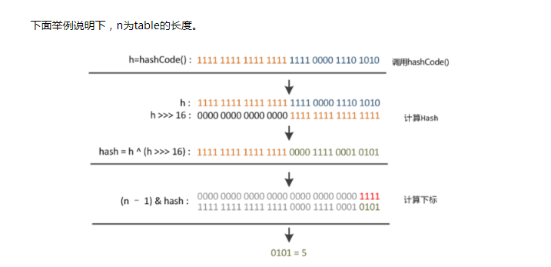

**6.扩容机制：**

我们使用的是2次幂的扩展(指长度扩为原来的2倍)所以，元素的位置要么是在原位置，要么是在原位置在移动2次幂的位置。

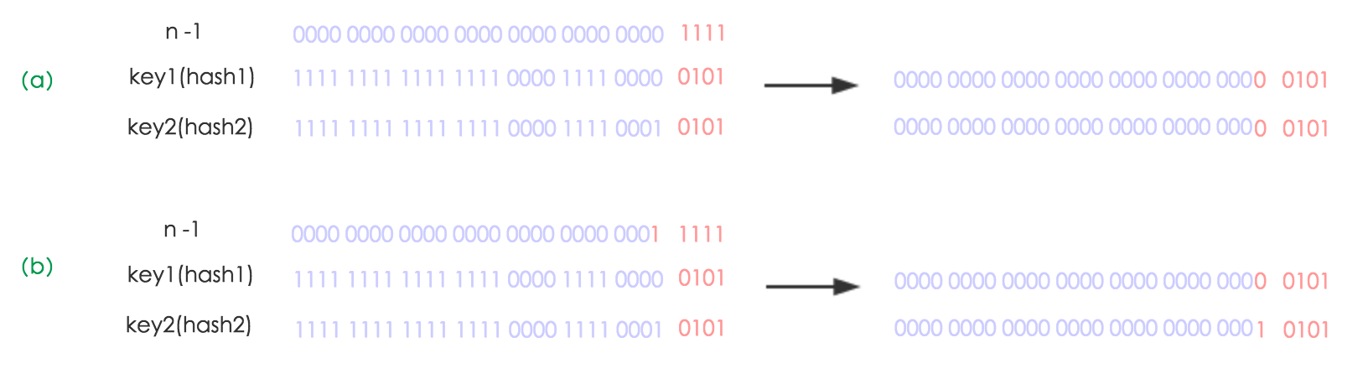

**图a，表示扩容前的key1和key2两种key确定索引的位置，**

**图b，表示扩容后的key1和key2两种key确定索引位置的示例。**

**元素在重新计算hash之后，因为n变为2倍，那么n-1的mask范围在高位多1bit(红色),因此新的index就会发生这样的变化：**

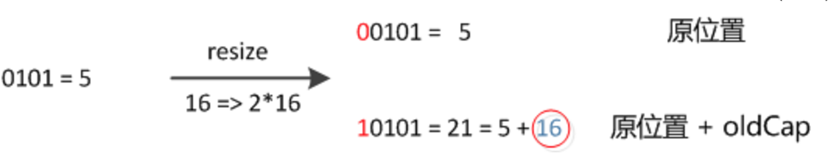

***因此，我们在扩充HashMap的时候，不需要像JDK1.7的实现那样重新计算hash，只需要看看原来的hash值新增的那个bit是1还是0就好了，是0的话索引没变，是1的话索引变成“原索引+oldCap”，可以看看下图为16扩充为32的resize示意图：***

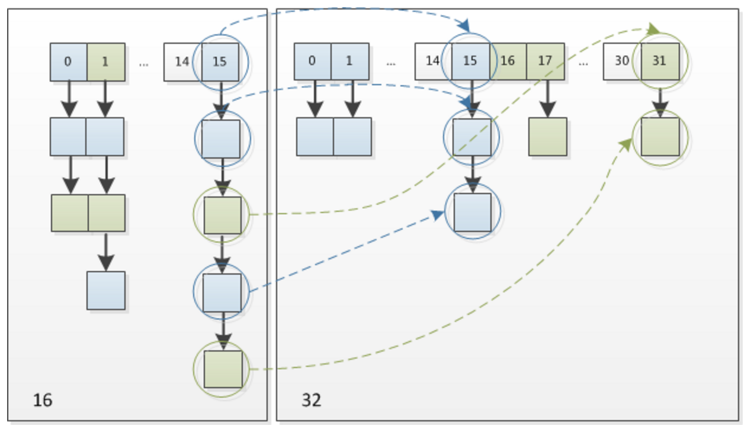

***这个设计确实非常的巧妙，既省去了重新计算hash值的时间，而且同时，由于新增的1bit是0还是1可以认为是随机的，因此resize的过程，均匀的把之前的冲突的节点分散到新的bucket了。这一块就是JDK1.8新增的优化点。***

1. **线程安全机制：**

**线程不安全，多线程环境中应尽量使用ConcurrentHashMap。**

***(1) 扩容是一个特别耗性能的操作，所以当程序员在使用HashMap的时候，估算map的大小，初始化的时候给一个大致的数值，避免map进行频繁的扩容。***

***(2) 负载因子是可以修改的，也可以大于1，但是建议不要轻易修改，除非情况非常特殊。***

***(3) HashMap是线程不安全的，不要在并发的环境中同时操作HashMap，建议使用ConcurrentHashMap。***

***(4) JDK1.8引入红黑树大程度优化了HashMap的性能。***

***(5) 还没升级JDK1.8的，现在开始升级吧。HashMap的性能提升仅仅是JDK1.8的冰山一角。***

**借鉴文章：**[**http://www.importnew.com/20386.html**](http://www.importnew.com/20386.html) **(通过这篇文章，知道了什么才是在学习)**

jdk源码分析五 java.util.hashSet (since 1.2)

1. **搞完HashMap之后，hashSet就很简单了。这里顺便就把HashSet带过了。**

**一、签名**

|  |
| --- |
| **public class HashSet<E>**  **extends AbstractSet<E>**  **implements Set<E>, Cloneable, java.io.Serializable** |

**二、成员变量**

|  |
| --- |
| **private transient HashMap<E,Object> map; //hashSet底层用HashMap实现。** |
| **private static final Object PRESENT = new Object();** |

**三、构造方法**

|  |
| --- |
| **public HashSet() {**  **map = new HashMap<>();**  **}** |
| **public HashSet(Collection<? extends E> c) {**  **map = new HashMap<>(Math.max((int) (c.size()/.75f) + 1, 16));**  **addAll(c);**  **}** |
| **public HashSet(int initialCapacity, float loadFactor) {**  **map = new HashMap<>(initialCapacity, loadFactor);**  **}** |
| **public HashSet(int initialCapacity) {**  **map = new HashMap<>(initialCapacity);**  **}** |
| **HashSet(int initialCapacity, float loadFactor, boolean dummy) {**  **map = new LinkedHashMap<>(initialCapacity, loadFactor);**  **}** |

**四、成员方法：**

|  |
| --- |
| **public boolean isEmpty() {**  **return map.isEmpty();**  **}** |
| **public boolean contains(Object o) {**  **return map.containsKey(o);**  **}** |
| **public boolean add(E e) {**  **return map.put(e, PRESENT)==null;**  **}** |
| **public boolean remove(Object o) {**  **return map.remove(o)==PRESENT;**  **}** |

**五、遍历方式：**

1. **总结:**

**看了HashMap之后，在看这个真的一点要敲黑板的地方都没有！~**

jdk源码分析六 java.util.HashTable<K,V> since 1.0

1. **签名**

|  |
| --- |
| **public class Hashtable<K,V>**  **extends Dictionary<K,V>**  **implements Map<K,V>, Cloneable, java.io.Serializable {** |

**Dictionary接口：所有包含key和value的抽象父类。**

1. **成员变量**

|  |
| --- |
| **private transient Entry<?,?>[] table; //** |
| **private transient int count; // table的大小** |
| **private int threshold; // 阈值** |
| **private float loadFactor; // 装载因子** |
| **private transient int modCount = 0; //用于fast-fial策略，记录结构修改次数。** |
| **private static class Entry<K,V> implements Map.Entry<K,V> { //单向链表。**  **final int hash;**  **final K key;**  **V value;**  **Entry<K,V> next;**  **protected Entry(int hash, K key, V value, Entry<K,V> next) {**  **this.hash = hash;**  **this.key = key;**  **this.value = value;**  **this.next = next;**  **}**  **@SuppressWarnings("unchecked")**  **protected Object clone() {**  **return new Entry<>(hash, key, value,**  **(next==null ? null : (Entry<K,V>) next.clone()));**  **}**  **// Map.Entry Ops**  **public K getKey() {**  **return key;**  **}**  **public V getValue() {**  **return value;**  **}**  **public V setValue(V value) {**  **if (value == null)**  **throw new NullPointerException();**  **V oldValue = this.value;**  **this.value = value;**  **return oldValue;**  **}**  **public boolean equals(Object o) {**  **if (!(o instanceof Map.Entry))**  **return false;**  **Map.Entry<?,?> e = (Map.Entry<?,?>)o;**  **return (key==null ? e.getKey()==null : key.equals(e.getKey())) &&**  **(value==null ? e.getValue()==null : value.equals(e.getValue()));**  **}**  **public int hashCode() {**  **return hash ^ Objects.hashCode(value);**  **}**  **public String toString() {**  **return key.toString()+"="+value.toString();**  **}**  **}** |

1. **构造方法**

|  |
| --- |
| **public Hashtable(int initialCapacity, float loadFactor) {**  **if (initialCapacity < 0)**  **throw new IllegalArgumentException("Illegal Capacity: "+**  **initialCapacity);**  **if (loadFactor <= 0 || Float.isNaN(loadFactor))**  **throw new IllegalArgumentException("Illegal Load: "+loadFactor);**  **if (initialCapacity==0)**  **initialCapacity = 1;**  **this.loadFactor = loadFactor;**  **table = new Entry<?,?>[initialCapacity];**  **threshold = (int)Math.min(initialCapacity * loadFactor, MAX_ARRAY_SIZE + 1);**  **}** |
| **public Hashtable(int initialCapacity) {**  **this(initialCapacity, 0.75f);**  **}** |
| **public Hashtable() {**  **this(11, 0.75f); //这里直接写死了，默认大小就是11. 装载**  **}** |
| **public Hashtable(Map<? extends K, ? extends V> t) {**  **this(Math.max(2*t.size(), 11), 0.75f);**  **putAll(t);**  **}** |

1. **成员方法**

|  |
| --- |
| **public synchronized int size() {**  **return count;**  **}** |
| **public synchronized boolean isEmpty() {**  **return count == 0;**  **}** |
| **public synchronized Enumeration<K> keys() {**  **return this.<K>getEnumeration(KEYS);**  **}** |
| **public synchronized Enumeration<V> elements() {**  **return this.<V>getEnumeration(VALUES);**  **}** |
| **public synchronized boolean contains(Object value) {**  **if (value == null) {**  **throw new NullPointerException();**  **}**  **Entry<?,?> tab[] = table;**  **for (int i = tab.length ; i-- > 0 ;) {**  **for (Entry<?,?> e = tab[i] ; e != null ; e = e.next) {**  **if (e.value.equals(value)) {**  **return true;**  **}**  **}**  **}**  **return false;**  **}** |
| **public synchronized boolean containsKey(Object key) {**  **Entry<?,?> tab[] = table;**  **int hash = key.hashCode();**  **int index = (hash & 0x7FFFFFFF) % tab.length;**  **for (Entry<?,?> e = tab[index] ; e != null ; e = e.next) {**  **if ((e.hash == hash) && e.key.equals(key)) {**  **return true;**  **}**  **}**  **return false;**  **}** |
| **public synchronized V get(Object key) {**  **Entry<?,?> tab[] = table;**  **int hash = key.hashCode();**  **int index = (hash & 0x7FFFFFFF) % tab.length;**  **for (Entry<?,?> e = tab[index] ; e != null ; e = e.next) {**  **if ((e.hash == hash) && e.key.equals(key)) {**  **return (V)e.value;**  **}**  **}**  **return null;**  **}** |
| **public synchronized V put(K key, V value) {**  **// Make sure the value is not null**  **if (value == null) { // 值也不允许为空！**  **throw new NullPointerException();**  **}**  **// Makes sure the key is not already in the hashtable.**  **Entry<?,?> tab[] = table;**  **int hash = key.hashCode();**  **int index = (hash & 0x7FFFFFFF) % tab.length;**  **@SuppressWarnings("unchecked")**  **Entry<K,V> entry = (Entry<K,V>)tab[index];**  **for(; entry != null ; entry = entry.next) {**  **if ((entry.hash == hash) && entry.key.equals(key)) {**  **V old = entry.value;**  **entry.value = value;**  **return old;**  **}**  **}**  **addEntry(hash, key, value, index);**  **return null;**  **}** |
| **private void addEntry(int hash, K key, V value, int index) {**  **modCount++;**  **Entry<?,?> tab[] = table;**  **if (count >= threshold) {**  **// Rehash the table if the threshold is exceeded**  **rehash(); // 扩容处理。**  **tab = table;**  **hash = key.hashCode();**  **index = (hash & 0x7FFFFFFF) % tab.length;**  **}**  **// Creates the new entry.**  **@SuppressWarnings("unchecked")**  **Entry<K,V> e = (Entry<K,V>) tab[index];**  **tab[index] = new Entry<>(hash, key, value, e);**  **count++;**  **}** |

1. **总结**
2. **HashTable是基于Dictionary类的、**
3. **Hashtable中的方法是同步的，保证了hashTable中对象的线程安全。**
4. **内部实现是数组加链表。默认大小是11，增加的方式是old*2+1；**
5. **Hashtable中，key和value都不能为空。**

Jdk源码分析七 java.util.LinkedHashMap since1.4

1. **签名**

|  |
| --- |
| **public class LinkedHashMap<K,V>**  **extends HashMap<K,V>**  **implements Map<K,V>** |

**实现了Map接口，继承了HashMap。**

1. **成员变量**

|  |
| --- |
| **transient LinkedHashMap.Entry<K,V> head; //// 双向链表的头** |
| **transient LinkedHashMap.Entry<K,V> tail; // 双向链表的尾** |
| **final boolean accessOrder; //控制读取的顺序，true表示访问的顺序，false表示插入的顺序**  **默认为false。** |
|  |

1. **构造方法**

|  |
| --- |
| **public HashSet() {**  **map = new HashMap<>();**  **}** |
| **transient LinkedHashMap.Entry<K,V> head;** |
| **transient LinkedHashMap.Entry<K,V> tail;** |
| **final boolean accessOrder;** |
| **HashSet(int initialCapacity, float loadFactor, boolean dummy) {**  **map = new LinkedHashMap<>(initialCapacity, loadFactor);**  **} // 注意了 这里是LinkedHashMap。** |

1. **成员方法**

|  |
| --- |
| **public V get(Object key) {**  **Node<K,V> e;**  **if ((e = getNode(hash(key), key)) == null)**  **return null;**  **if (accessOrder)**  **afterNodeAccess(e);**  **return e.value;**  **}** |
| **final Node<K,V> getNode(int hash, Object key) {**  **Node<K,V>[] tab; Node<K,V> first, e; int n; K k;**  **if ((tab = table) != null && (n = tab.length) > 0 &&**  **(first = tab[(n - 1) & hash]) != null) {**  **if (first.hash == hash && // always check first node**  **((k = first.key) == key || (key != null && key.equals(k))))**  **return first;**  **if ((e = first.next) != null) {**  **if (first instanceof TreeNode)**  **return ((TreeNode<K,V>)first).getTreeNode(hash, key);**  **do {**  **if (e.hash == hash &&**  **((k = e.key) == key || (key != null && key.equals(k))))**  **return e;**  **} while ((e = e.next) != null);**  **}**  **}**  **return null;**  **}** |
| **void afterNodeAccess(Node<K,V> e) { // move node to last**  **LinkedHashMap.Entry<K,V> last;**  **if (accessOrder && (last = tail) != e) {**  **LinkedHashMap.Entry<K,V> p =**  **(LinkedHashMap.Entry<K,V>)e, b = p.before, a = p.after;**  **p.after = null;**  **if (b == null)**  **head = a;**  **else**  **b.after = a;**  **if (a != null)**  **a.before = b;**  **else**  **last = b;**  **if (last == null)**  **head = p;**  **else {**  **p.before = last;**  **last.after = p;**  **}**  **tail = p;**  **++modCount;**  **}**  **}** |

**put方法和HashMap的方法一致。**

|  |
| --- |
| **public boolean containsValue(Object value) {**  **for (LinkedHashMap.Entry<K,V> e = head; e != null; e = e.after) {**  **V v = e.value;**  **if (v == value || (value != null && value.equals(v)))**  **return true;**  **}**  **return false;**  **}** |

**contiainsValue方法，就是遍历整个linkedHashMap,将每个Entry的value都比较一下。**

1. **遍历方式 略**
2. **总结**

**1.accessOrder的作用。**

**False的情况下(默认)，按照插入时候的顺序来访问每个元素。**

**True的情况，每次调用get(K k)的时候，都会对HashTable发生改变。它会按照访问顺序来改变HashTable结构。**

Jdk源码分析八 java.util.TreeMap since 1.2

1. **签名**

|  |
| --- |
| **public class TreeMap<K,V>**  **extends AbstractMap<K,V>**  **implements NavigableMap<K,V>, Cloneable, java.io.Serializable** |

**NavigableMap：可导航的Map。 Since 1.6. 它实现继承了SortedMap,成为了一个具有搜索匹配算法的Map。和TreeSet类似。**

1. **成员变量**

|  |
| --- |
| **private final Comparator<? super K> comparator; // 比较器。** |
| **private transient Entry<K,V> root; // 树的根节点** |
| **private transient int size = 0; // 树的entity数量** |
| **private transient int modCount = 0;** |
| **static final class Entry<K,V> implements Map.Entry<K,V> {**  **K key;**  **V value;**  **Entry<K,V> left;**  **Entry<K,V> right;**  **Entry<K,V> parent;**  **boolean color = BLACK;**  **/\*\***  **\* Make a new cell with given key, value, and parent, and with**  **\* {@code null} child links, and BLACK color.**  **\*/**  **Entry(K key, V value, Entry<K,V> parent) {**  **this.key = key;**  **this.value = value;**  **this.parent = parent;**  **}**  **/\*\***  **\* Returns the key.**  **\***  **\* @return the key**  **\*/**  **public K getKey() {**  **return key;**  **}**  **/\*\***  **\* Returns the value associated with the key.**  **\***  **\* @return the value associated with the key**  **\*/**  **public V getValue() {**  **return value;**  **}**  **/\*\***  **\* Replaces the value currently associated with the key with the given**  **\* value.**  **\***  **\* @return the value associated with the key before this method was**  **\* called**  **\*/**  **public V setValue(V value) {**  **V oldValue = this.value;**  **this.value = value;**  **return oldValue;**  **}**  **public boolean equals(Object o) {**  **if (!(o instanceof Map.Entry))**  **return false;**  **Map.Entry<?,?> e = (Map.Entry<?,?>)o;**  **return valEquals(key,e.getKey()) && valEquals(value,e.getValue());**  **}**  **public int hashCode() {**  **int keyHash = (key==null ? 0 : key.hashCode());**  **int valueHash = (value==null ? 0 : value.hashCode());**  **return keyHash ^ valueHash;**  **}**  **public String toString() {**  **return key + "=" + value;**  **}**  **}** |

1. **构造方法**

|  |
| --- |
| **public TreeMap() { //构造一个新的，空的tree map，使用key的自然顺序(没有指定比较器)。**  **comparator = null;**  **}** |
| **public TreeMap(Comparator<? super K> comparator) { // 根据指定的比较器构造一个**  **this.comparator = comparator; //新TreeMap**  **}** |
| **public TreeMap(Map<? extends K, ? extends V> m) { //将给定的map构造一个新treeMap**  **comparator = null; // 但是按照key的自然顺序排序。**  **putAll(m);**  **}** |
| **public TreeMap(SortedMap<K, ? extends V> m) {**  **comparator = m.comparator();**  **try {**  **buildFromSorted(m.size(), m.entrySet().iterator(), null, null);**  **} catch (java.io.IOException cannotHappen) {**  **} catch (ClassNotFoundException cannotHappen) {**  **}**  **}//将给定SortMap中的数据根据SortMap中的比较器构造一个新的TreeMap。** |

1. **成员方法**

|  |
| --- |
| **public V put(K key, V value) {**  **Entry<K,V> t = root;**  **if (t == null) {**  **compare(key, key); // type (and possibly null) check**  **root = new Entry<>(key, value, null);**  **size = 1;**  **modCount++;**  **return null;**  **}**  **int cmp;**  **Entry<K,V> parent;**  **// split comparator and comparable paths**  **Comparator<? super K> cpr = comparator;**  **if (cpr != null) {**  **do {**  **parent = t;**  **cmp = cpr.compare(key, t.key);**  **if (cmp < 0)**  **t = t.left;**  **else if (cmp > 0)**  **t = t.right;**  **else**  **return t.setValue(value);**  **} while (t != null);**  **}**  **else {**  **if (key == null)**  **throw new NullPointerException();**  **@SuppressWarnings("unchecked") // 如果没有指定比较器。就将key强转成比较器。**  **Comparable<? super K> k = (Comparable<? super K>) key;**  **do {**  **parent = t;**  **cmp = k.compareTo(t.key);**  **if (cmp < 0)**  **t = t.left;**  **else if (cmp > 0)**  **t = t.right;**  **else**  **return t.setValue(value);**  **} while (t != null);**  **}**  **Entry<K,V> e = new Entry<>(key, value, parent);**  **if (cmp < 0)**  **parent.left = e;**  **else**  **parent.right = e;**  **fixAfterInsertion(e);**  **size++;**  **modCount++;**  **return null;**  **}** |

|  |
| --- |
| **public void putAll(Map<? extends K, ? extends V> map) {**  **int mapSize = map.size();**  **if (size==0 && mapSize!=0 && map instanceof SortedMap) {**  **Comparator<?> c = ((SortedMap<?,?>)map).comparator();**  **if (c == comparator || (c != null && c.equals(comparator))) {**  **++modCount;**  **try {**  **buildFromSorted(mapSize, map.entrySet().iterator(),**  **null, null);**  **} catch (java.io.IOException cannotHappen) {**  **} catch (ClassNotFoundException cannotHappen) {**  **}**  **return;**  **}**  **}**  **super.putAll(map);**  **}** |
| **private void buildFromSorted(int size, Iterator<?> it,**  **java.io.ObjectInputStream str,**  **V defaultVal)**  **throws java.io.IOException, ClassNotFoundException {**  **this.size = size;**  **root = buildFromSorted(0, 0, size-1, computeRedLevel(size),**  **it, str, defaultVal);**  **}** |
| **// 从排序序列中构造TreeMap函数。**  **private final Entry<K,V> buildFromSorted(int level, int lo, int hi,**  **int redLevel,**  **Iterator<?> it,**  **java.io.ObjectInputStream str,**  **V defaultVal)**  **throws java.io.IOException, ClassNotFoundException { //**    **// 树的根节点 肯定是排序序列的中间树。**  **// 递归处理根节点的左树，右树。**  **if (hi < lo) return null;**  **int mid = (lo + hi) >>> 1;**  **Entry<K,V> left = null;**  **if (lo < mid)**  **left = buildFromSorted(level+1, lo, mid - 1, redLevel,**  **it, str, defaultVal);**  **// extract key and/or value from iterator or stream**  **K key;**  **V value;**  **if (it != null) {**  **if (defaultVal==null) {**  **Map.Entry<?,?> entry = (Map.Entry<?,?>)it.next();**  **key = (K)entry.getKey();**  **value = (V)entry.getValue();**  **} else {**  **key = (K)it.next();**  **value = defaultVal;**  **}**  **} else { // use stream**  **key = (K) str.readObject();**  **value = (defaultVal != null ? defaultVal : (V) str.readObject());**  **}**  **Entry<K,V> middle = new Entry<>(key, value, null);**  **// color nodes in non-full bottommost level red**  **if (level == redLevel)**  **middle.color = RED;**  **if (left != null) {**  **middle.left = left;**  **left.parent = middle;**  **}**  **if (mid < hi) {**  **Entry<K,V> right = buildFromSorted(level+1, mid+1, hi, redLevel,**  **it, str, defaultVal);**  **middle.right = right;**  **right.parent = middle;**  **}**  **return middle;**  **}** |

**查找:**

|  |
| --- |
| **final Entry<K,V> getFirstEntry() {**  **Entry<K,V> p = root;**  **if (p != null)**  **while (p.left != null)**  **p = p.left;**  **return p;**  **} //中序遍历 获取第一个Entity** |
| **final Entry<K,V> getLastEntry() {**  **Entry<K,V> p = root;**  **if (p != null)**  **while (p.right != null)**  **p = p.right;**  **return p;**  **} // 中序遍历 获取最后一个entity。** |

**删除**

|  |
| --- |
| **private void deleteEntry(Entry<K,V> p) {**  **modCount++;**  **size--;**  **// If strictly internal, copy successor's element to p and then make p**  **// point to successor.**  **if (p.left != null && p.right != null) {**  **Entry<K,V> s = successor(p);**  **p.key = s.key;**  **p.value = s.value;**  **p = s;**  **} // p has 2 children**  **// Start fixup at replacement node, if it exists.**  **Entry<K,V> replacement = (p.left != null ? p.left : p.right);**  **if (replacement != null) {**  **// Link replacement to parent**  **replacement.parent = p.parent;**  **if (p.parent == null)**  **root = replacement;**  **else if (p == p.parent.left)**  **p.parent.left = replacement;**  **else**  **p.parent.right = replacement;**  **// Null out links so they are OK to use by fixAfterDeletion.**  **p.left = p.right = p.parent = null;**  **// Fix replacement**  **if (p.color == BLACK)**  **fixAfterDeletion(replacement);**  **} else if (p.parent == null) { // return if we are the only node.**  **root = null;**  **} else { // No children. Use self as phantom replacement and unlink.**  **if (p.color == BLACK)**  **fixAfterDeletion(p);**  **if (p.parent != null) {**  **if (p == p.parent.left)**  **p.parent.left = null;**  **else if (p == p.parent.right)**  **p.parent.right = null;**  **p.parent = null;**  **}**  **}**  **}** |
| **static <K,V> TreeMap.Entry<K,V> successor(Entry<K,V> t) {**  **if (t == null)**  **return null;**  **else if (t.right != null) {**  **Entry<K,V> p = t.right;**  **while (p.left != null)**  **p = p.left;**  **return p;**  **} else {**  **Entry<K,V> p = t.parent;**  **Entry<K,V> ch = t;**  **while (p != null && ch == p.right) {**  **ch = p;**  **p = p.parent;**  **}**  **return p;**  **}**  **}** |

1. **遍历方式**
2. **总结**
3. **红黑树。**

**从Entiry这个内部类可以看出，TreeMap是使用红黑树这种数据结构来实现的。(By the way, hashMap中也用到了红黑树。)**

**大体上说一下红黑树的性质吧，这个我会在以后学习一下的。。。。。。。。**

**每个节点或是red，或是Black。**

**根节点是Black的。**

**每个叶子节点NIL是black的。**

**如果一个节点是Red，那么它的两个子节点都是Black。**

**对于每个节点，从该节点到其所有后代叶节点的简单路径上，均包含相同数目的Black节点。**

1. **TreeMap在涉及到树形结构变化的时候，所实现的代码都是根据算法导论中的伪代码来的。**

**如果想研究一下红黑树的变化原理，请参考这篇文章：**[**http://www.importnew.com/20413.html**](http://www.importnew.com/20413.html)

**至此，基础的集合源码 就看到这里了。**

**当然，我只是大体上看了一下。日后还会仔细研读一下。顺便纠正一下我写的这些小小的总结。**

**接下来就行，一个比较厉害的类源码了。**

**ConcurrentHashMap. 这个作为一个后续的任务吧。因为 目前我对并发的理解还不到位，可以说是还没有入门。等我看完了juc(java.util.concurrent)包中的源码，再来总结一下，ConcurrentHashMap。 这个部分的源码，我也得好好的吸收一下。**

**方小白 2017年11月18日。**